**Notes on post-hoc Bonferroni-testing with repeated measures in R**

The phoc() function gives the same results as a worked example using SPSS from this website (note you must run library(ez) for phoc() to work)

<http://www.microbiologybytes.com/maths/spss4.html>

subsection Two-Way Repeated Measures ANOVA light blue table, Treatment, Weedkiller, Flamethrower

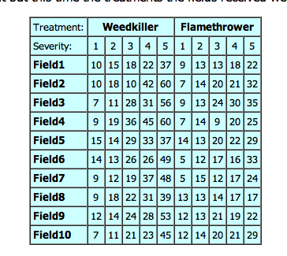

This table is in an R-readable form in the same website from which you have downloaded the phoc() function as weed.txt. The SPSS example carries out a post-hoc test on the within-subjects factor Severity and reports the following results of a Bonferroni t-tests:

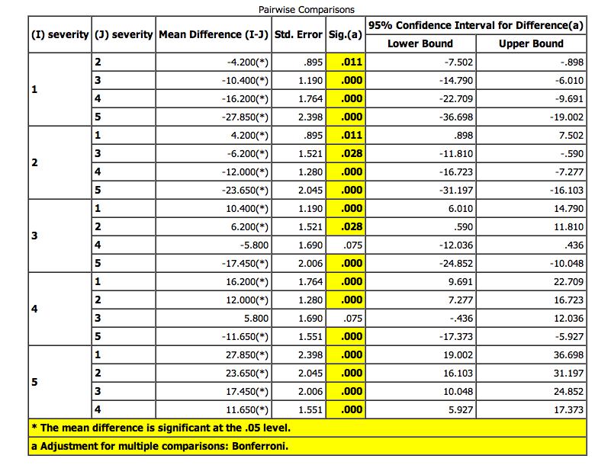

We get exactly the same results with phoc() as follows:

# read in the data

weed = read.table(file.path(pfad, "weed.txt"))

# source phoc.txt which gives two functions: phoc() and phsel()

source(file.path(pfad, "phoc.txt"))

# run library(ez)

library(ez)

We now try and do a post-hoc test on the factor Sev. This will (correctly) fail because there are repeated measures (two measures per Sev per subject)

phoc(weed, .(field), .(Subj), .(Sev))

Error in phoc(weed, .(field), .(Subj), .(Sev)) :

Unique values per subject-factor combination required; aggregate over factors and try again

So we must aggregate first over Sev:

weedm = with(weed, aggregate(field, list(Subj, Sev), mean))

# give names to the columns

names(weedm) = c("Subj", "Sev", "field")

# redo

ph = phoc(weedm, .(field), .(Subj), .(Sev))

round(ph$res, 3)

t df prob-adj

1-2 -4.692 9 0.011

1-3 -8.741 9 0.000

1-4 -9.183 9 0.000

1-5 -11.614 9 0.000

2-3 -4.077 9 0.028

2-4 -9.374 9 0.000

2-5 -11.563 9 0.000

3-4 -3.432 9 0.075

3-5 -8.698 9 0.000

4-5 -7.511 9 0.000

These are the same probabilities as those highlighted in yellow in the SPSS calculation. Therefore, there is strong evidence (!) that this phoc() function does exactly what SPSS does in applying a post-hoc Bonferroni test to repeated measures.

See the above lecture *Die Varianzanalyse mit Messwiederholungen* for further details.

Jonathan Harrington

29.6.11